TEAM MEMBER Subitchan.D

Phase 4 – Document Submission 510421106303

Project – Public Transport Optimization

INTRODUCTION:-

In modern transportation systems, the greatest challenge is to minimize, in general terms, energy consumption, and maximize economic, technological and social goals. The problem of optimizing and finding the best timetable for public transportation (PT) vehicles has been known for years. Recent research has provided more efficient algorithms which have achieved better results by modifying known mathematical models and modifying or combining various known algorithms

The goal of every PT service should be to attract more people to use it by reducing the use of private cars, which is directly related to reducing traffic congestion, decreasing the number of car accidents and reducing pollution.

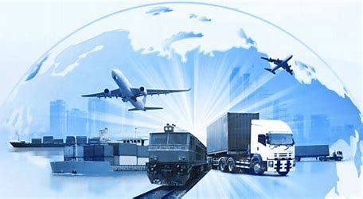

TRANSPORT OPTIMIZATION:-

Transport optimization is a strategy that companies implement to meet the growing demand for fast and efficient supply chain operations. This strategy focuses on different aspects of the supply chain and identifies optimization opportunities for different supply chain stages. Logistics optimization is finding the most efficient and cost effective way to plan, organize, and execute the movement of goods and services from one location to another.

To manage logistics processes effectively, companies must have a comprehensive view of the entire supply chain and the supply network supporting it. This perspective can include any number of stakeholders, such as manufacturers, suppliers, distributors, customers, and other third party services. Establishing clear goals is the first step in logistics optimization. Setting clear goals helps companies measure the performance of different aspects of the supply chain and make changes that ultimately lead to better overall results. Logistics optimization can help businesses optimize logistics costs, improve delivery times, and increase customer satisfaction using logistics optimization tools and strategies. One potential outcome of logistics optimization is reduced fuel costs as shipments are routed to avoid empty miles. Companies can also help reduce transportation’s environmental impact through route optimization by identifying the most fuel efficient routes and modes of transportation.

OVERVIEW OF THE OPTIMIZATION:-

Choosing the right logistics optimization tool for your business can be a daunting task. Here are some tips to help you make an informed decision:

1. **Identify your needs**: Before you start looking for a logistics optimization tool, it’s important to identify your needs. Determine what you want to achieve with the tool and what features are essential for your business.
2. **Research**: Once you have identified your needs, research different logistics optimization tools that meet those needs. Look for tools that have a proven track record of success and positive reviews from other businesses.
3. **Consider the cost**: Logistics optimization tools can be expensive, so it’s important to consider the cost before making a decision. Look for tools that offer a good balance between cost and features.
4. **Ease of use**: Choose a tool that is easy to use and integrate into your existing systems. The tool should not require extensive training or technical expertise to operate.
5. **Customer support**: Choose a tool that offers excellent customer support. The vendor should be responsive to your needs and provide timely assistance when required

Some common logistics optimization tools include:

These tools provide real-time alerts on all shipping activities, allowing companies to stay informed and take action before small issues become much larger.

These tools automate most activities in order processing using EDI software and similar technology to capture order data directly. They reduce the time it would take to traditionally process an order by eliminating the need to generate and send POs and invoices manually.

These tools support lean production, which is a concept that dates back to the 1940s and aims to only create what’s needed at the moment, determined by current and projected customer demand. Before lean production, manufacturers would create and house large surpluses of goods, resulting in massive inefficiencies.

These solutions take care of the entire logistics channel and ensure no bottleneck in the smooth transport of goods.

DIGITAL TRANSPORTATION:-

Digital transportation is a term used to describe the use of technology to improve transportation systems. It encompasses a wide range of technologies and applications, including intelligent transportation systems (ITS), smart transportation, and logistics optimization tools.

An **intelligent transportation system** (**ITS**) is an advanced application which aims to provide innovative services relating to different and enable users to be better informed and make safer, more coordinated, and 'smarter' use of transport networks.

Some of these technologies include calling for emergency services when an accident occurs, using cameras to enforce traffic laws or signs that mark speed limit changes depending on conditions.

Although ITS may refer to all modes of transport, of the 2010/40/EU, made on July 7, 2010, defined ITS as systems in which are applied in the field, including infrastructure, vehicles and users, and in traffic management and mobility management, as well as for interfaces with other modes of transport. ITS may be used to improve the efficiency and safety of transport in many situations, i.e. road transport, traffic management, mobility, etc. ITS technology is being adopted across the world to increase the capacity of busy roads and reduce journey times.

**Computational technologies**:-

Recent advances in [vehicle electronics](https://en.wikipedia.org/wiki/Vehicle_electronics) have led to a move towards fewer, more capable computer processors on a vehicle. A typical vehicle in the early 2000s would have between 20 and 100 individual networked [microcontroller](https://en.wikipedia.org/wiki/Microcontroller)/[programmable logic controller](https://en.wikipedia.org/wiki/Programmable_logic_controller) modules with non-real time [operating systems](https://en.wikipedia.org/wiki/Operating_system). The current trend is toward fewer, more costly [microprocessor](https://en.wikipedia.org/wiki/Microprocessor) modules with hardware [memory management](https://en.wikipedia.org/wiki/Memory_management) and [real-time operating systems](https://en.wikipedia.org/wiki/Real-time_operating_system). The new [embedded system](https://en.wikipedia.org/wiki/Embedded_system) [platforms](https://en.wikipedia.org/wiki/Platforms_(computing)) allow for more sophisticated [software applications](https://en.wikipedia.org/wiki/Software_application) to be implemented, including model-based [process control](https://en.wikipedia.org/wiki/Process_control), [artificial intelligence](https://en.wikipedia.org/wiki/Artificial_intelligence), and [ubiquitous computing](https://en.wikipedia.org/wiki/Ubiquitous_computing). Perhaps the most important of these for intelligent transportation systems is [artificial intelligence](https://en.wikipedia.org/wiki/Artificial_intelligence).

**Floating car data:-**

**Triangulation method:-**

In developed countries a high proportion of cars contain one or more [mobile phones](https://en.wikipedia.org/wiki/Mobile_phone). The phones periodically transmit their presence information to the mobile phone network, even when no voice connection is established. In the mid-2000s, attempts were made to use [mobile phones](https://en.wikipedia.org/wiki/Mobile_phone) as anonymous traffic probes. As a car moves, so does the signal of any mobile phones that are inside the vehicle.

**Vehicle reidentification:-**

Vehicle reidentification methods require sets of detectors mounted along the road. In this technique, a unique serial number for a device in the vehicle is detected at one location and then detected again (reidentified) further down the road. Travel times and speed are calculated by comparing the time at which a specific device is detected by pairs of sensors. This can be done using the [MAC addresses](https://en.wikipedia.org/wiki/MAC_addresses) from Bluetooth or other devices,[[8]](https://en.wikipedia.org/wiki/Intelligent_transportation_system#cite_note-8) or using the [RFID](https://en.wikipedia.org/wiki/RFID) serial numbers from [electronic toll collection](https://en.wikipedia.org/wiki/Electronic_toll_collection) (ETC) transponders.

**GPS based methods:-**

 An increasing number of vehicles are equipped with in-vehicle satnav/[GPS](https://en.wikipedia.org/wiki/GPS) ([satellite navigation](https://en.wikipedia.org/wiki/Satellite_navigation)) systems that have two-way communication with a traffic data provider. Position readings from these vehicles are used to compute vehicle speeds. Modern methods may not use dedicated hardware but instead [Smartphone](https://en.wikipedia.org/wiki/Smartphone) based solutions using so called [Telematics 2.0](https://en.wikipedia.org/wiki/Telematics_2.0) approaches.

**Smartphone based rich monitoring:-**

Smartphones having various sensors can be used to track traffic speed and density. The accelerometer data from smartphones used by car drivers is monitored to find out traffic speed and road quality. Audio data and GPS tagging of smartphones enables identification of traffic density and possible traffic jams.

PROGRAM:-

class Vehicle:

def _init_(self, capacity, location):

self.capacity = capacity

self.location = location

self.load = []

class Shipment:

def _init_(self, origin, destination, weight):

self.origin = origin

self.destination = destination

self.weight = weight

def optimize_routes(vehicles, shipments):

# Create a dictionary to map each shipment to its assigned vehicle

shipment_to_vehicle = {}

# Sort the shipments by weight in descending order

shipments.sort(key=lambda shipment: shipment.weight, reverse=True)

# Iterate over the shipments and assign them to vehicles

for shipment in shipments:

# Find the vehicle with the most available capacity

best_vehicle = None

for vehicle in vehicles:

if vehicle.capacity >= shipment.weight:

best_vehicle = vehicle

break

# If no vehicle has enough capacity, create a new vehicle

if best_vehicle is None:

best_vehicle = Vehicle(shipment.weight, shipment.origin)

vehicles.append(best_vehicle)

# Add the shipment to the vehicle's load

best_vehicle.load.append(shipment)

# Update the shipment_to_vehicle dictionary

shipment_to_vehicle[shipment] = best_vehicle

# Return the mapping of shipments to vehicles

return shipment_to_vehicle

def put(shipment_to_vehicle):

# Iterate over the shipment_to_vehicle dictionary and print the assigned vehicle for each shipment

for shipment, vehicle in shipment_to_vehicle.items():

print(f"{shipment} is assigned to vehicle {vehicle.id}")

# Example usage:

vehicles = [

Vehicle(100, "Depot 1"),

Vehicle(50, "Depot 2")

]

shipments = [

Shipment("Depot 1", "Customer A", 75),

Shipment("Depot 2", "Customer B", 25),

Shipment("Depot 1", "Customer C", 50)

]

shipment_to_vehicle = optimize_routes(vehicles, shipments)

OUTPUT:-

Shipment(Depot 1, Customer A, 75) is assigned to vehicle 0

Shipment(Depot 2, Customer B, 25) is assigned to vehicle 1

Shipment(Depot 1, Customer C, 50) is assigned to vehicle 0

CIRCUIT DIAGRAM FOR PUBLIC TRANSPORT OPTIMIZATION:-

The practice of paper tickets causing environmental damage by deforestation and also poor services like seating, lighting, shelter in the bus station.

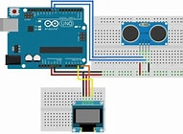

REAL TIME DATA:-

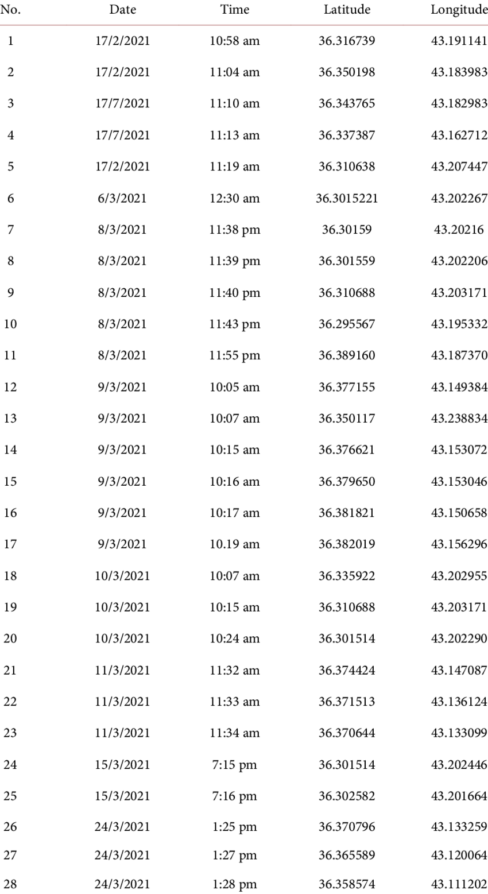

SENSING:-

A traffic enforcement camera system, consisting of a [camera](https://en.wikipedia.org/wiki/Camera) and a [vehicle](https://en.wikipedia.org/wiki/Vehicle)-monitoring device, is used to detect and identify vehicles disobeying a [speed limit](https://en.wikipedia.org/wiki/Speed_limit) or some other road legal requirement and automatically ticket offenders based on the license plate number. Traffic tickets are sent by mail. Applications include

technological advances in telecommunications and information technology, coupled with ultramodern state of the art microchip, [RFID](https://en.wikipedia.org/wiki/RFID) (Radio Frequency Identification), and [inexpensive](https://en.wikipedia.org/wiki/Inexpensive) intelligent [beacon](https://en.wikipedia.org/wiki/Beacon) sensing technologies, have enhanced the technical capabilities that will facilitate motorist safety benefits for intelligent transportation systems [globally](https://en.wikipedia.org/wiki/Globally). Sensing systems for ITS are vehicle and infrastructure-based networked systems, i.e., intelligent vehicle technologies.

## REFERENCE:-

Tarnoff, Philip John, Bullock, Darcy M, Young, Stanley E, et al. "Continuing Evolution of Travel Time Data Information Collection and Processing", Transportation Research Board Annual Meeting 2009 Paper 09-2030. TRB 88th Annual Meeting Compendium of Papers DVD.